

AFTER HOURS & RESPITE CARE
PARENT HANDBOOK

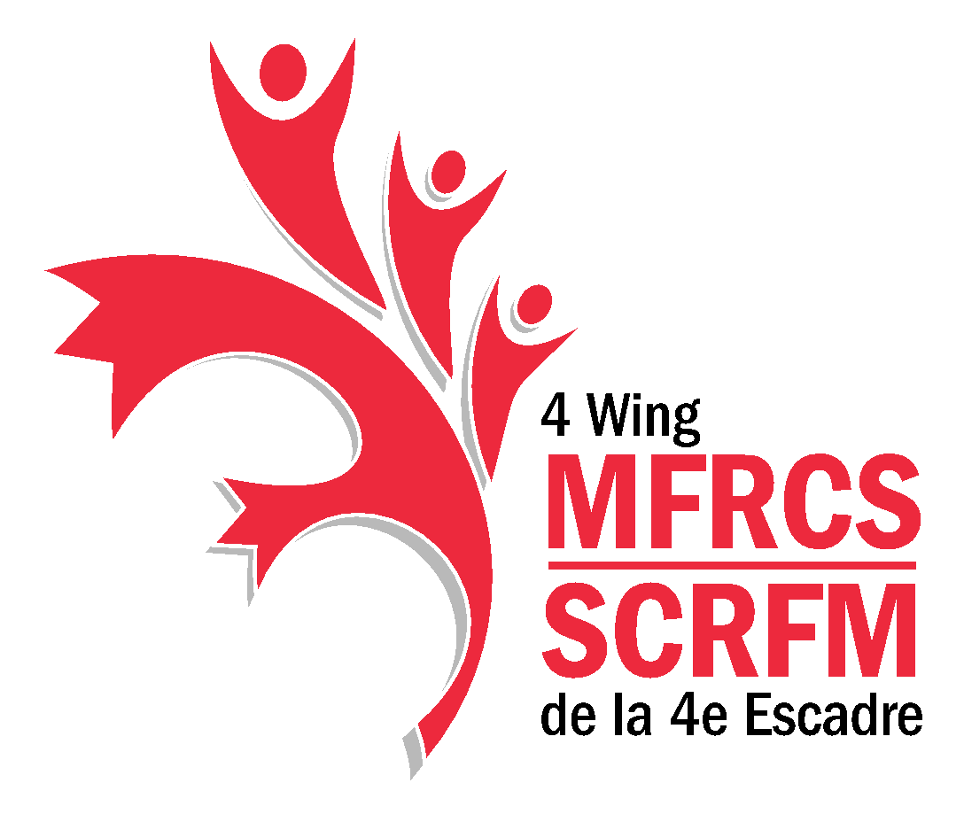

`
Contents
Welcome to MFRC First Flights After Hours Casual & Respite Care 1
MFRC After Hours Casual & Respite Care Philosophy 1
Hours of Operation 1
Enrollment 1
Casual Care Registration 2
Casual Care Fee Payment 2
Respite care 3
Late Pick Up 3
Release of Children Policy 3
Food Policy 4
Items from Home 4
Managing Ill Children 4
Building and Emergency Procedures 5
Parent/Guardian Contract and Acknowledgement of Understanding 6

Welcome to MFRC First Flights After Hours Casual & Respite Care

We hope you and your child will enjoy participating in our program and that your experience here will be a happy and meaningful one.

The policies outlined have been established with careful thought and planning to meet the needs of the children and families, as well as to allow for the efficient operation of the After Hours Casual & Respite Care centre.

All families are required to read and understand the policies outlined.

MFRC After Hours Casual & Respite Care Philosophy

The primary objective of the MFRC First Flights After Hours Casual & Respite Care program and its staff is to provide quality child care for each individual child after regular daycare hours in a safe and inviting environment, with qualified staff.

Hours of Operation

The MFRC First Flights After Hours Casual & Respite Care program is open 5:00 pm to 9:00 pm on most Fridays from September to June. The program is closed on all statutory holidays and any other designated days.

Enrollment

Enrollment for the After Hours Care program requires a registration form to be completed for each child. Families can visit our website at www.firstflightschildcare.com and complete the registration link for their children (register and join our waitlist link on home page). If the child is already using one of the MFRC First Flights child care programs, he/she will already have a registration profile and will not require another one to be completed.

An email will be sent to the family with information about the After Hours Care program along with the Parent Handbook. The Parent Handbook is to be fully read so parents are aware of the policies for the program. Once that is completed, your child will be given an After Hours Care membership and then parents will be able to register on PerfectMind. By registering their child to attend the After Hours Care or Respite program, parents acknowledge that they have read and agree to the policies in the Parent Handbook.

Casual Care Registration

Families can register their child(ren) to attend the After Hours Care program on a weekly basis, each week opens for booking one week prior to the date of care. To ensure fair access to all families, any family using the After Hours Care program one week will not be eligible to register the following week unless there is still space available on the day of care. Families can inquire if care may still be available by contacting the MFRC office directly at 780-594-6006 on Friday’s by 12:00 pm.

Bookings for Casual Care can be book and paid for online through PerfectMind website. Registration for each week closes on PerfectMind Thursday’s at 4:00 pm.

The steps to register on PerfectMind are:

- Create an account, including children using the After Hours Care https://4wingmfrcs.perfectmind.com
- In order to book online, the First Flights Coordinator at MFRCS will have to set your children up with an AHC Membership. To receive this membership, once you have created an account, you are required to complete the child’s registration form by completing the link on our First Flights website, www.firstflightschildcare.com. (Only children with registration forms will receive membership)
- After you have been all set up, you are able to book and pay through PerfectMind.
- We have limited spaces. If spaces are full already, please add your child/ children to the waitlist and we will contact you should a space become available.
Casual Care fees must be paid at the time of booking

Cancellations must be made by calling the MFRCS front desk at 780-594-6006 by Tuesday by 3:00 pm in the same week that care would take place for a refund to be issued. Cancellations made after Tuesday at 3:00 pm for any reason, will not have fees refunded.

Casual Care Fee Payment

The cost for care is $10.00/per day for your first child, $5.00/per day for additional children from the same family.

Parents will be charged when registering for an After Hours Care session and must pay through the PerfectMind website for online registrations or at MFRCS reception at the time of booking. If the child is picked up early, this will not reduce the fee.

Respite care

Respite care, consists of one four (4) hour block of care at no cost and is offered up to once per week, through the Deployment Coordinator or medical support (conditional to approval by the Executive Director). To ensure fair access to all families, any family using the Respite Care program one week will not be eligible to register the following week unless there is still space available on the day of care. Families can inquire if care may still be available by contacting the MFRC office directly on Friday’s by 12:00 pm.

Bookings for Respite Care can be taken over the phone at 780-594-6006 or booked in person at the front office of the 4 Wing MFRC.

Cancellations must be made by calling the MFRCS front desk at 780-594-6006 by Tuesday at 3:00 pm in the same week that care would take place or respite care may be denied in the future.

Late Pick Up

If the child is picked up late, a charge of $5.00 for every five (5) minutes over will occur.

- After the 5-minute time period, the emergency contact person will be called if parents cannot be contacted.
- Should staff be unable to contact that person after half an hour (30 minutes), the Military Police will be called and asked for assistance in locating the parents.
- A ‘Late Pick Up’ form will be given to the parent to sign. The First Flights Child Care Coordinator/Manager will be notified.

Release of Children Policy

The First Flights After Hours Casual & Respite Care program staff shall release children in care only to the parent or guardian of the child, or to persons designated on the written release or contract. If a parent wishes to designate any person(s) not identified on the original written release to pick up a child, the parent must provide a handwritten, signed note to this effect, including appropriate identifying information before release is to take place. Children cannot be released to anyone under the age of 18. We will ask for picture ID of any person unknown to the staff.

Food Policy

Parents are responsible to provide any food their child(ren) will need during their time at the program, this includes meals and snacks along with a labelled water bottle.

Foods containing peanut or nut products are NOT permitted at the MFRC First Flights After Hours Casual & Respite Care program. If a child arrives with peanut or other nut products the parent will be called to provide a nut free alternative for their child.

Items from Home

Children must at all times, have a change of clothing available at the centre (shirt, pants, underwear, socks and running shoes). Clean shoes are required for indoor play.

During the warmer months, sunscreen is required to be brought to the centre for outdoor play and bug spray if the family chooses to use it on their child(ren).

Children who are not fully toilet trained will be accepted into the program but are required to have a sufficient supply of diapers and wipes for the time they are at the program. The parent will be called to bring more if a sufficient supply is not brought with your child.

The program has an adequate supply of toys. Children may bring a favourite toy with the understanding:

- The staff will not be responsible for any loss of, or damage to a personal toy brought to the program.
- All toys from home are labelled.

Managing Ill Children

When a staff member has reason to believe that a child is ill, the child must be immediately removed from the Child Care Program by the parent or emergency contact person. A parent/guardian or alternate designated person must be available to answer the call from the program at all times. If your child attends school or a child care program during the day and was sent home from the school/program due to illness, he/she is not able to attend the After Hours Care program.

A sick child is defined as a child who is unable to participate in the Child Care Program because he/she is:

- Vomiting, has a fever, diarrhea or a new unexplained rash or cough;
- Requires greater attention than can be provided without compromising the care of other children in the program;
- Displays any other illness or symptoms that a staff member knows or believes may indicate the child poses a health risk to persons on the program’s premises.

Building and Emergency Procedures

- Fire Drills are held at least once a month. Fire Drills are conducted at various times during the care. If a parent is in the Centre at the time of a Fire Drill, the parent is also required to actively participate in the drill. If a parent arrives at After Hours Care while the children are going outside or are waiting outside for clearance to return to the building, the parent may not enter the building in advance of the children. The Fire Safety Checklist is posted beside the fire extinguisher in the cubby area.
- In the event of a power outage, the following guidelines are implemented:
  - If the power outage lasts for more than one hour, the building loses heat, and the emergency lights go off. The After Hours Care staff will notify the parents by telephone that they must pick up their child as soon as possible, and not more than one hour after the call is placed. In the summer when the weather is nice and we can run the program outside; an exception may be considered.
  - If the Wing Commander orders a stand down due to a power outage, all parents are required to pick up their children within one hour of the start of the stand down
- If water is cut off for more than an hour, unsanitary conditions arise. Personal hygiene cannot be maintained. Every effort will be made to relocate, however if this is not possible, parents will be called to pick up their children. Staff will take portable records for all children in the event of an emergency evacuation.

Parent/Guardian Contract and Acknowledgement of Understanding

I,

(Parent or Guardian name)

I understand that by registering my child to attend the First Flights After Hours Care and Respite program, I have read and understood the policies and procedures outlined in the MFRC First Flights After Hours Casual & Respite Care policy manual.

I understand that I must be available to be reached by phone at all times or have communicated to the staff of the program, a contact person for the evening.

(Child’s name)

I have also been given the opportunity to ask questions and have been notified that I can communicate with the staff any future questions or concerns that may arise.

Signed:

(Parent or Guardian signature) (Date)

(First Flights Child Care Coordinator signature) (Date)

